Collection Bin Guidelines

STEP #1:
We recommend purchasing $5 to $10 plastic 10-gallon non-clear bins (as shown here) from your neighborhood Wal-Mart, Target or similar retail store.
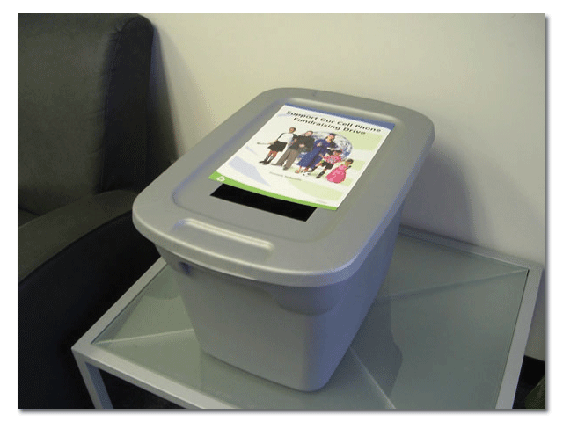
STEP #2:
Carefully cut a rectangular slot wide enough for a phone to be inserted but small enough to discourage people from reaching in and trying to remove phones. (as shown in photo above). NOTE: The rectangular shaped slot has been proven to reduce the amount of trash people attempt to place in the bin. That is, circle shaped holes remind people of garbage cans.
STEP #3:
Insert one of our FREE color mini-flyers into a protective clear plastic sleeve or laminate.
STEP #4:
Tape or glue (use glue on clear plastic sleeve only) the mini flyer to the top of the bin. Be careful not to cover the slot opening.
STEP #5: Optional
To reduce the chance of theft two small holes can be drilled through the plastic lid and into the bin base. Small zip ties or even a small travel padlock will ensure the bin remains closed at all times while on display.

