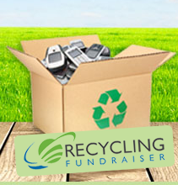

Save on Taxes.

Help our school.

Protect the Environment.

Donate your used electronics!

Dear Neighbor:

(Insert your organization name here) is conducting a recycling fundraiser. There’s nothing to buy. We are simply asking you to protect the environment by donating your used consumer electronics. Your used item(s) may be tax deductible and will be recycled in accordance with EPA regulations. 100% of the proceeds will help fund (insert your organization’s cause here).

We are currently collecting the following items:

Cell Phones | iPads & Tablets | Inkjet Cartridges

Please drop off any items you would like to recycle at: (Insert Your Organization's Drop Off Location and Collection Point Information.)

We greatly appreciate your support!

Best regards,

(Organization Name)
(Contact Name) / (Contact Phone #)

(Tear along dotted line and retain for your records)

Tax Deductible Donation Acknowledgement

Thank you for your donation. We cannot make any determination as to the value of the specific item(s) you have donated to us. Generally speaking, older items will not warrant a tax deduction (but still can be recycled). You should consult your tax advisor regarding value determination for tax purposes. The IRS requires the following information for tax deductions of $250 or less. Please fill in the information indicated below and retain this for your tax records.

(Insert organization name here) ____________ _______________________
Donation Organization Donation Date Description of item(s)

_______ $__________ ______________ _____________________

# of Items Value of Donation Donor’s Name Donor’s Address

